U4 SAC 1 Revision (2014 Past SAC questions)

Question 1
The systematic name for the molecule is:

- 2-ethyl-3-methyl-3-pentene
- octene
- 3,4-dimethyl-2-hexene
- 3-methyl-4-ethyl-2-pentene

Question 3
The species with the lowest solubility in water is:

- Decanoic acid
- Ethanoic acid
- Pentanoic acid
- Propanoic acid

Question 5
What two compounds react together in the presence of sulfuric acid to produce the compound with the structural formula given in the diagram?

- ethanoic acid and 1-butanol
- 2-propanoic acid and 1-propanol
- Butanoic acid and ethanol
- methyl propanoic acid and 1-propanol

Question 6
When a polyester forms from reaction between the monomers HOCH₂CH₂OH and HOOCC₆H₄COOH the percentage, by mass, of carbon in the polyester is:

- greater than in the monomers
- less than in the monomers
- the same as in the monomers
- dependent on the length of the polymer chain

Question 10
Which statement about compounds I and II is not true?

A. The ¹³C NMR spectrum of compound I has three peaks, and that of compound II has two peaks.
B. The low resolution 1H NMR spectrum of I has four peaks, and that of II has three peaks.
C. The mass spectrum of both will show a peak at a mass-to charge ratio of 60.
D. The fingerprint region of the IR spectra will be identical for both compounds.

Question 13
The Infrared spectrum of an organic compound is given below.
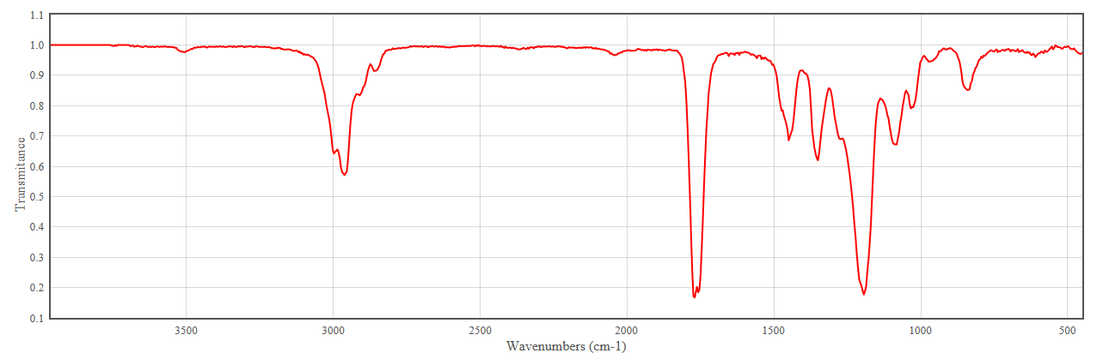
Wave numbers (cm⁻¹)
The molecule that produced this spectrum is most likely to be:
- CH₃COOCH₃
- CH₃CH₂COOH
- CH₃CH₂OH
- CH₃CH₂NH₂

SECTION B

QUESTION 1 (4 marks)
Question 1
- Draw the structural formula for propan-2-ol.

1 mark
- Using systematic nomenclature, name the compounds represented by the following formulas.

(i) CH₃CH₂CH₂CH₂CH₂CHOHCH₂CH₂CH₃ _______________________________________________
(ii) CH₃CH₂CH₂CHClCH₃ _______________________________________________
(iii) CH₃CH₂COOH _______________________________________________

3 marks

c) In the diagram below, the steps I, II and III represent industrial processes.
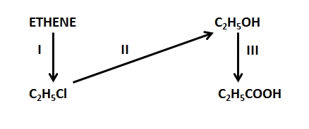

(i) Name the type of reaction indicated by process II __________________________________
(ii) Write the formula for the other reactant used in process II __________________________

(iii) Name the type of reaction indicated by process III__________________________________

(iv) Write the formula for the two other reactants required for in process III

(A) __________________________________ (B) __________________________________
4 marks
Total = 8 marks

Question 2
The molecular formula of a compound, Z is C₃H₆Br₂
- The mass spectrum of compound Z is shown below.
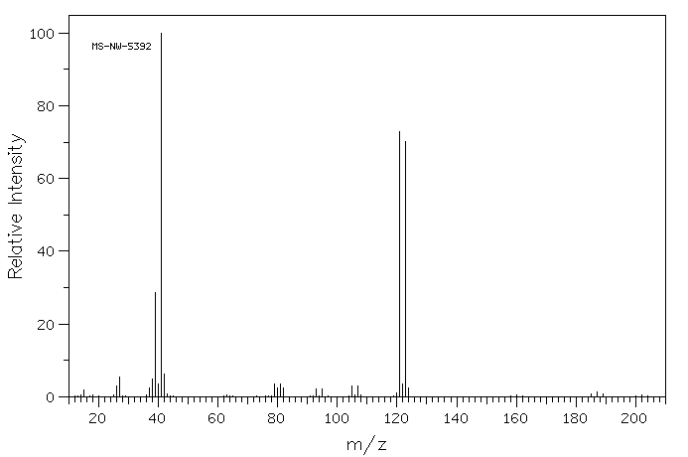
- The mass of the molecular ion is 200. Write an equation for the formation of this ion. No states are required.

1 mark

- What do the two peaks at m/z of 121 and 123 indicate about the relative abundance of ⁷⁹Br and ⁸¹Br? Give a reason for your answer.

2 marks

- Identify the molecular mass of the most abundant ion.

1 mark

- Compound Z has the following structure:

Write the systematic name of compound Z

1 mark

- The NMR spectrum of compound Z is shown below.

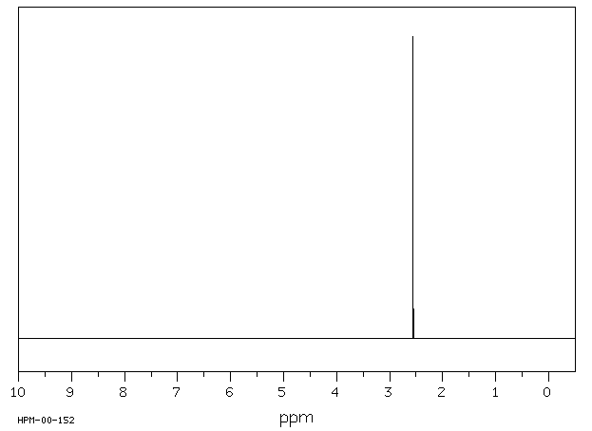 | 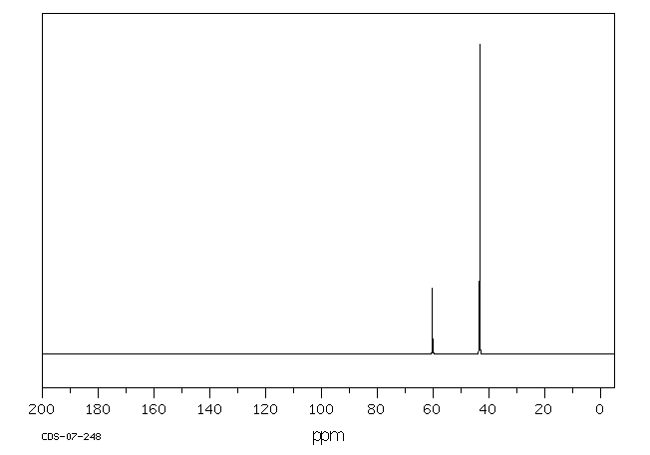
Spectrum B
Spectrum A

Which spectrum represents the ¹³C NMR of compound Z? Provide two valid explanations for your choice.

2 marks

Total = 7 marks

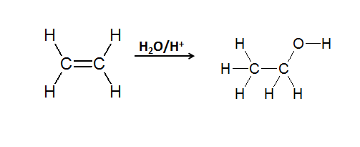
(i) Name the type of reaction shown in the equation.
1 mark

(ii) Would this ethanol be termed bioethanol? Explain your response.

2 marks

Total = 8 marks

Question 6
The structure of Compound X has the empirical formula of C₅H₁₀O_{2.} The mass spectrum, infrared spectrum and high resolution proton NMR spectrum for this compound are given below.

Mass Spectrum for Compound X
Mass spectrum
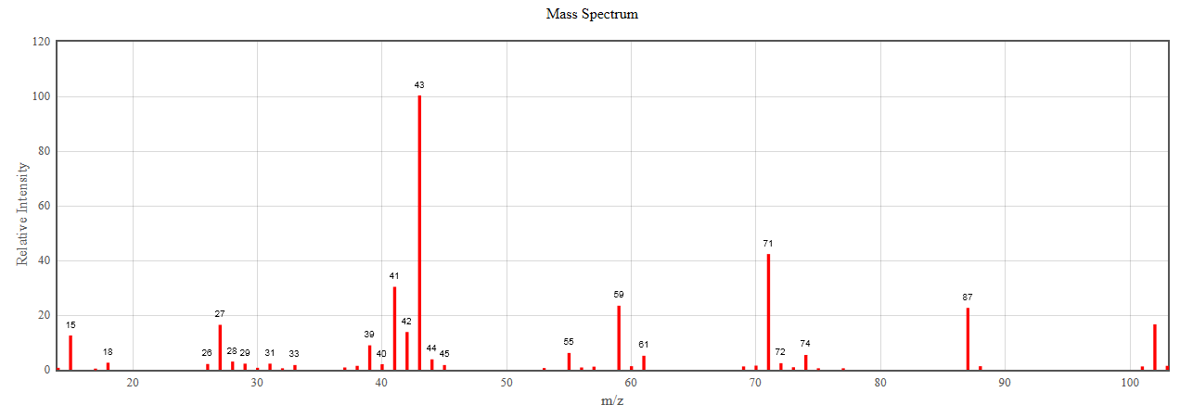
- (i) Give the formula of the component that produced the peak at mass/charge ratio 102.

1 mark

(ii) Account for the differences in structure for the components that produced the peaks at mass/charge ratio 102 and 103.

1 mark
(iii) Would an isomer of Compound X produce the same or different spectrum to that given above? Give a reason for your answer.

2 marks

Infrared spectrum
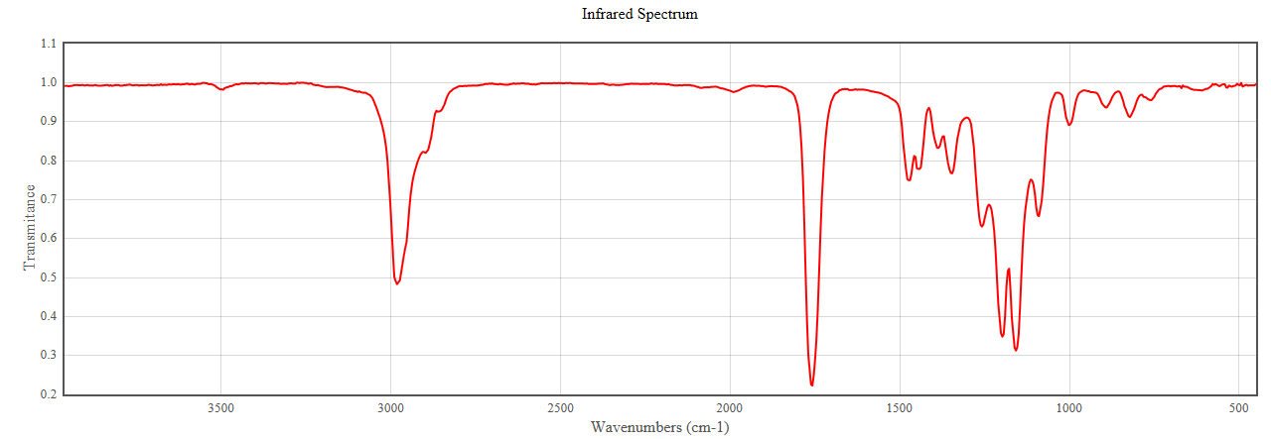
Wave numbers (cm⁻¹)
- (i) Use the infrared spectrum above to indicate the family of organic compounds to which compound X belongs. Give a reason to support your answer.

2 marks
(ii) Would an isomer of Compound X produce the same or different spectrum to that given above? Give a reason for your answer.

1 mark

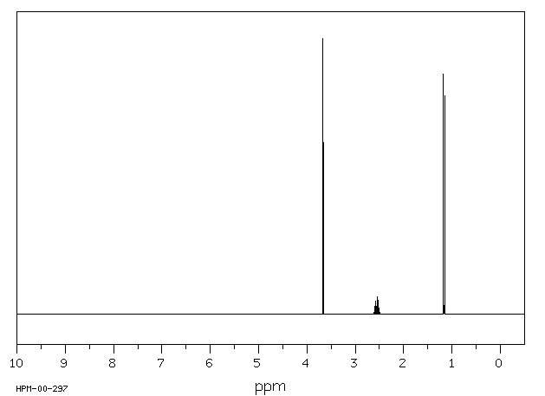
¹H NMR
Singlet; 3.7 ppm
Doublet; 1.2 ppm
Septet; 2.6 ppm

- Use the ¹H NMR spectrum above as well as the spectra from parts a) and b) to draw the structural formula of Compound X. Show all bonds

1 mark
Total = 8 marks

